|  |  |  |  |  |  |
| --- | --- | --- | --- | --- | --- |
| Date | 12-Dec-22 | | | Tester Name | Mayuri Patel |
| Environment | Penfax - Test | | | Login used |  |
| Operating System | Select OS | Version: | Update: | | |
| Software Used | Select Software | Version: | Update: | | |
| Select Software | Version: | Update: | | |
| Release version | 22.4.1 | | | | |
| Title | E15 Reports | | | | |
| Test Type | Regression | | | | |
| Test Scenario | E15.05 Process Breakage Capstock report | | | | |
|  |  | | | | |
| Expected Results | Report should be validated against Breakage Occurrences and General Ledger. | | | | |
| Pass/Fail | Pass | | | JIRA# |  |

Describe your steps with screenshots:

1. Log into Penfax. Go to Batches -> Batch Processes. Select PEPP Breakage Capstock Report from the dropdown. Click on Search. This batch is scheduled to run every day at 9 pm. Click on the Batch Process ID.

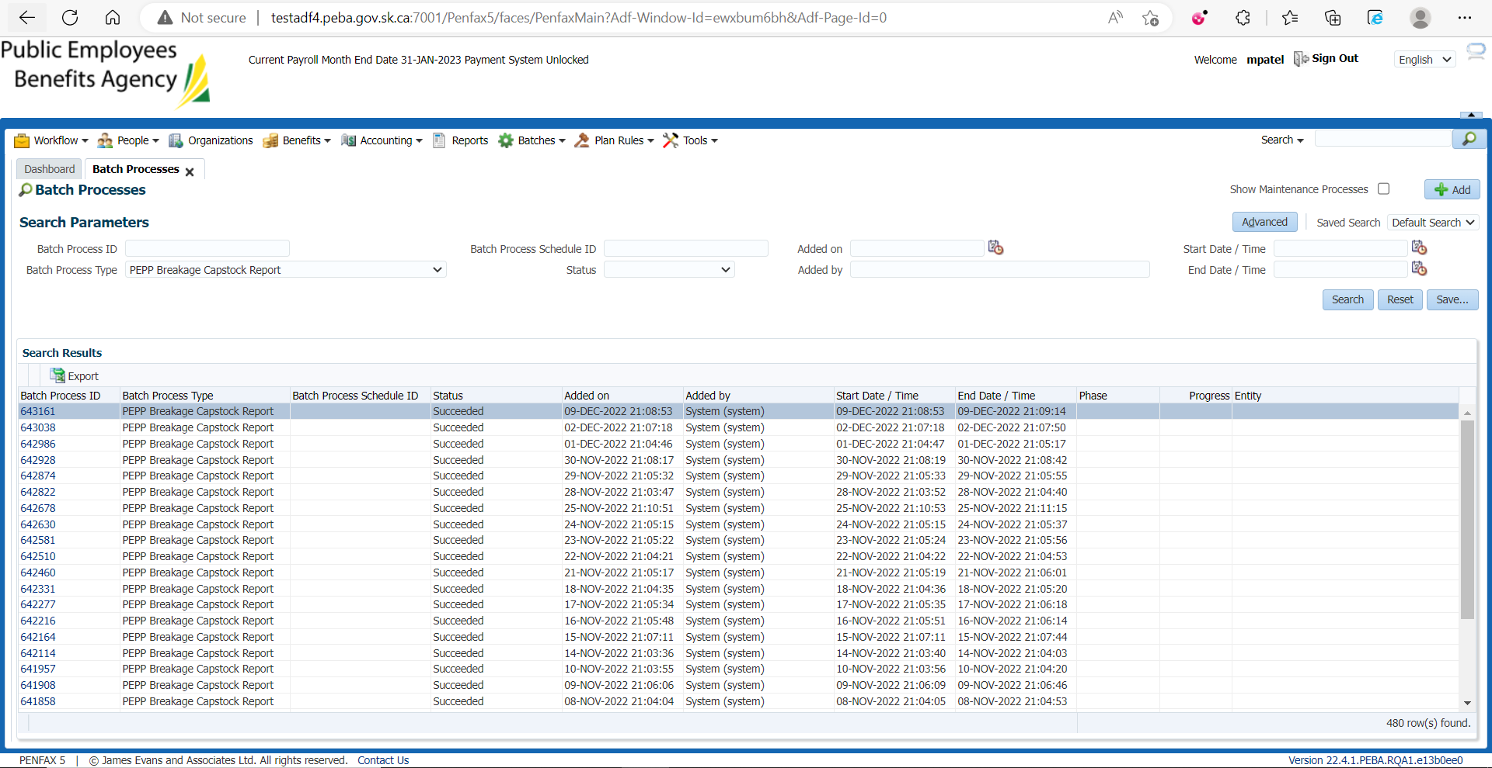

1. Go to Files tab. Open PEPP Breakage Capstock report.

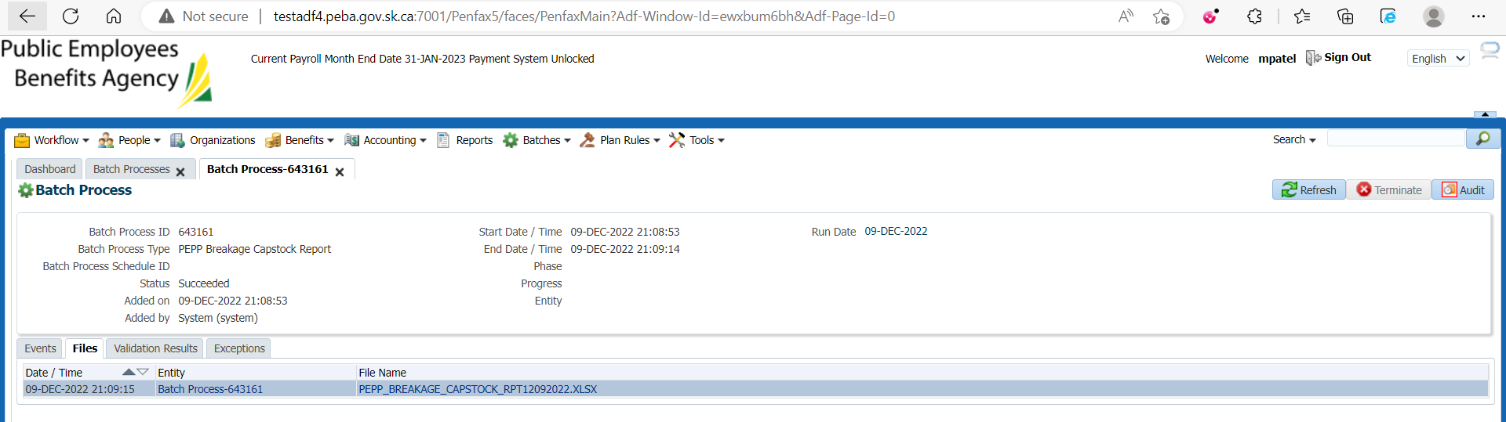

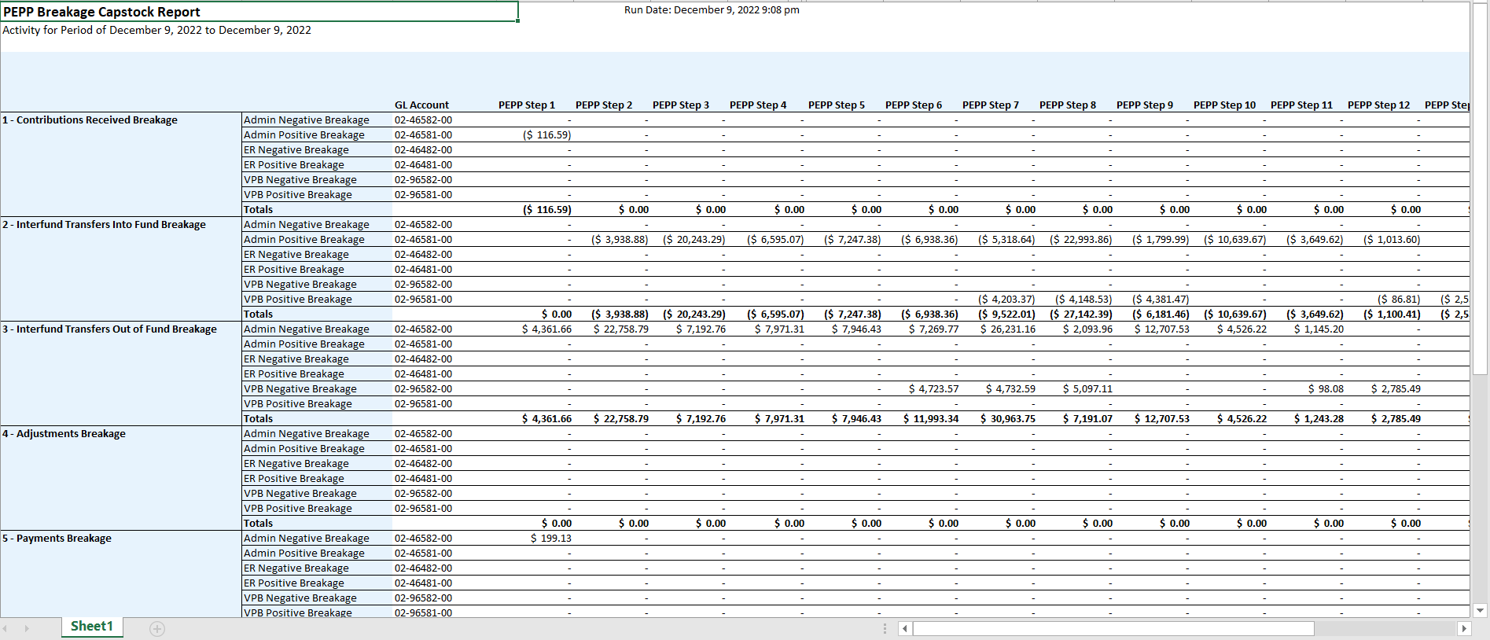

1. Go to Batches -> Breakage Occurrences. Search with plan and transaction date and validate the data against PEPP Breakage Capstock report.

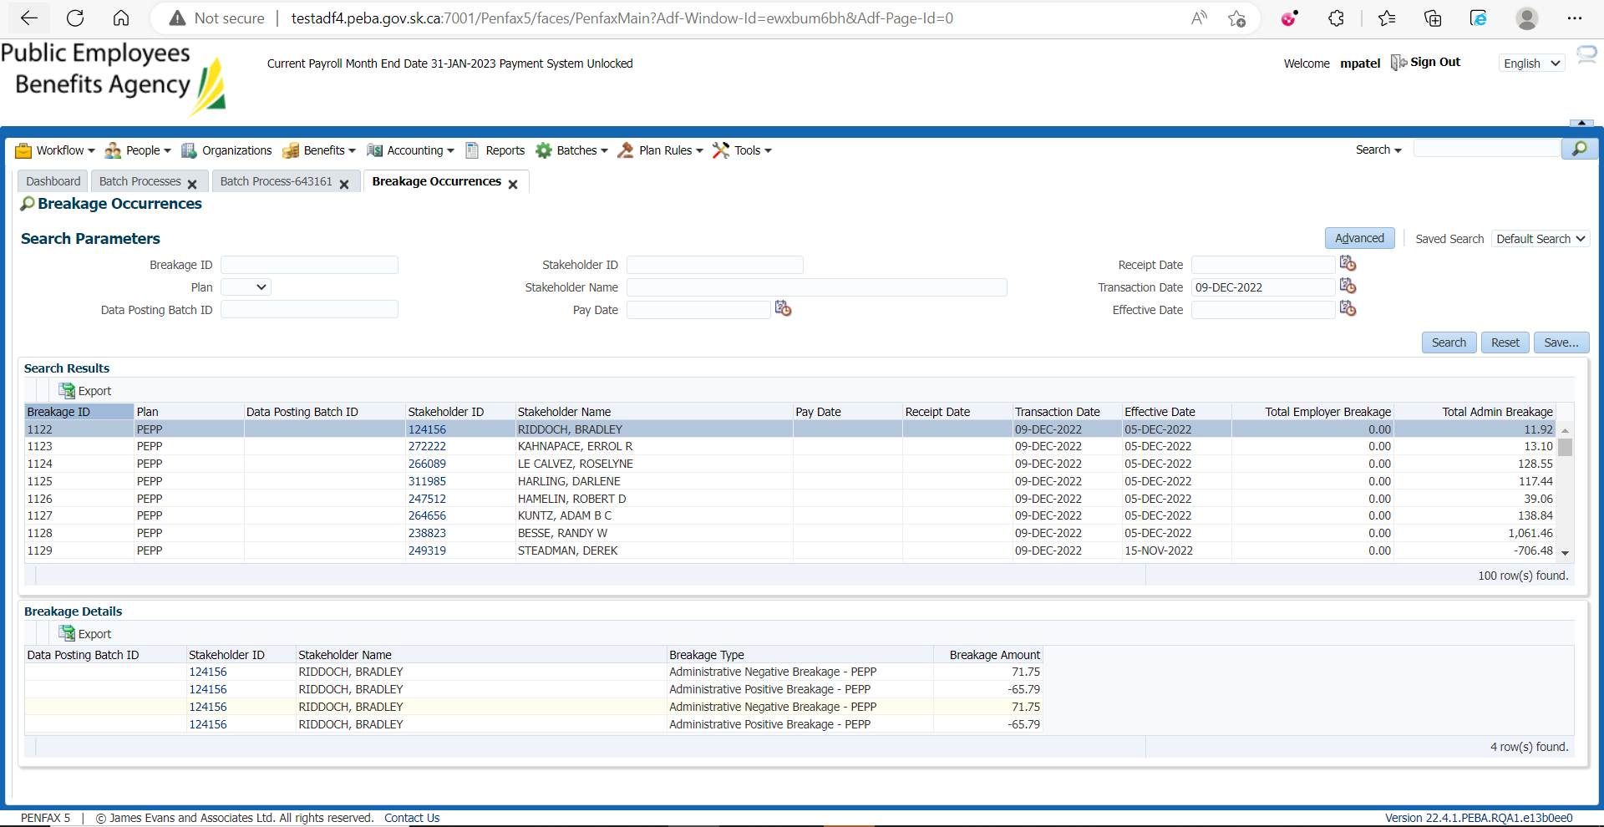

Here, (71.75)+(71.75)+(-65.79)+(-65.79)=11.92

1. Go to Accounting -> General Ledger -> General Ledger. Search with plan, account and journal entry date and validate data against PEPP Breakage Capstock report.

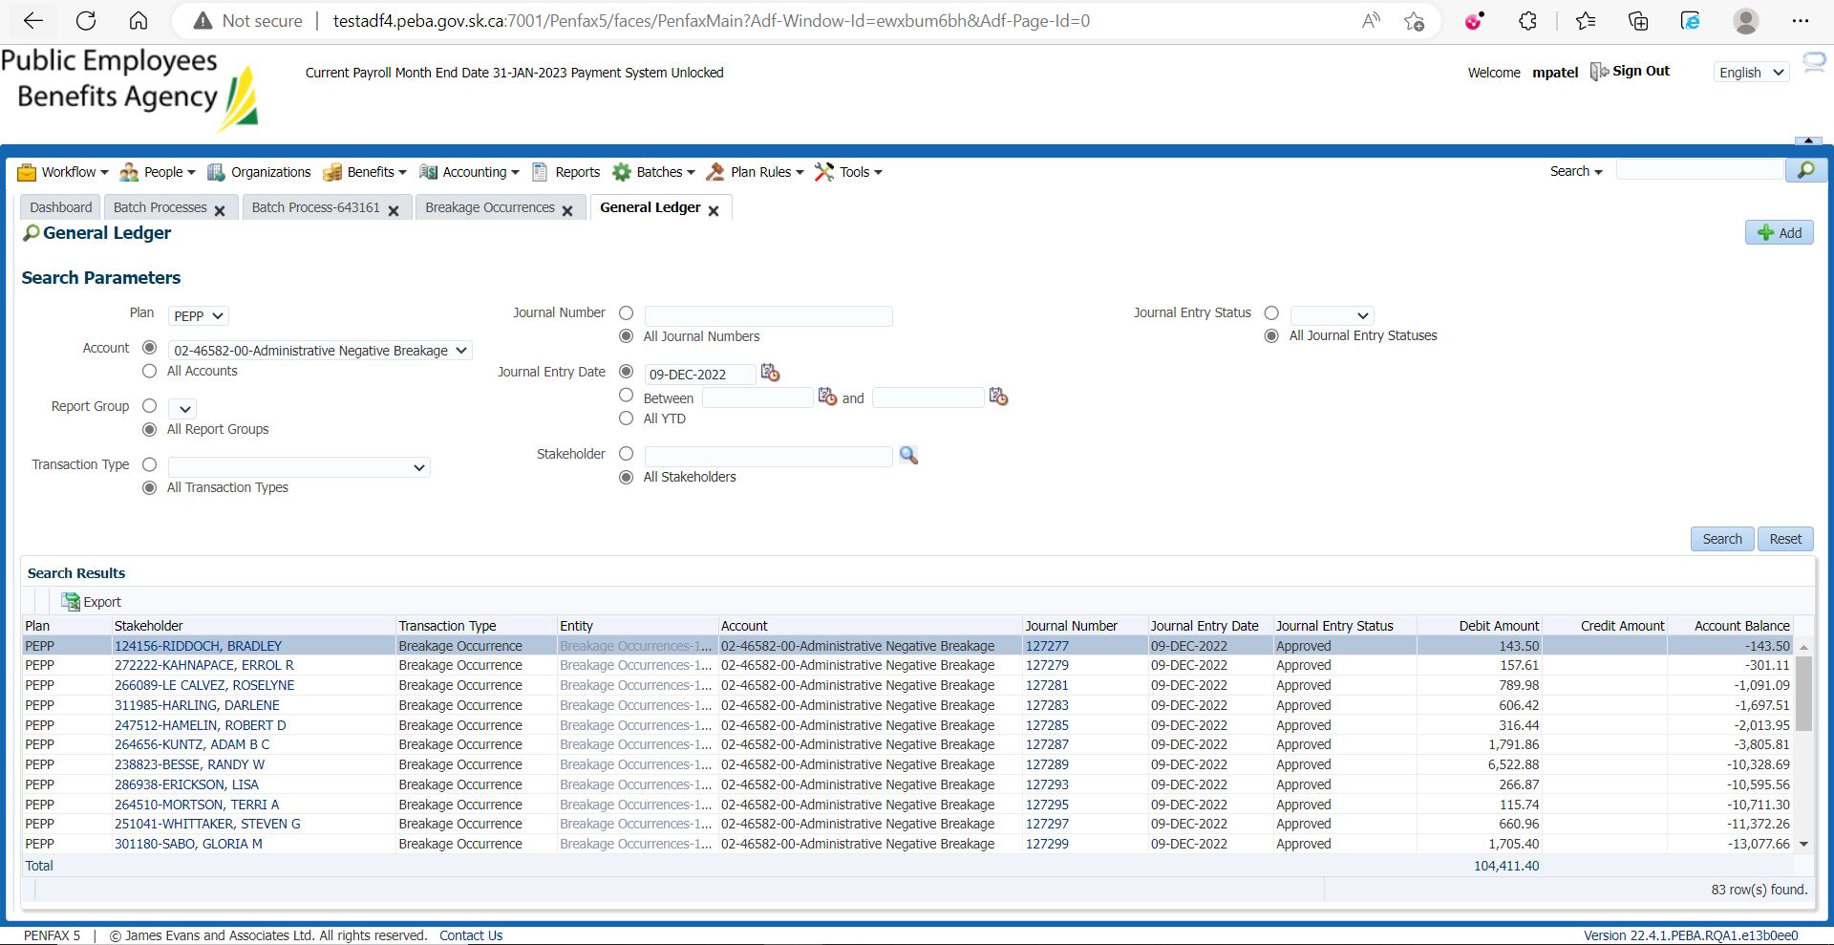

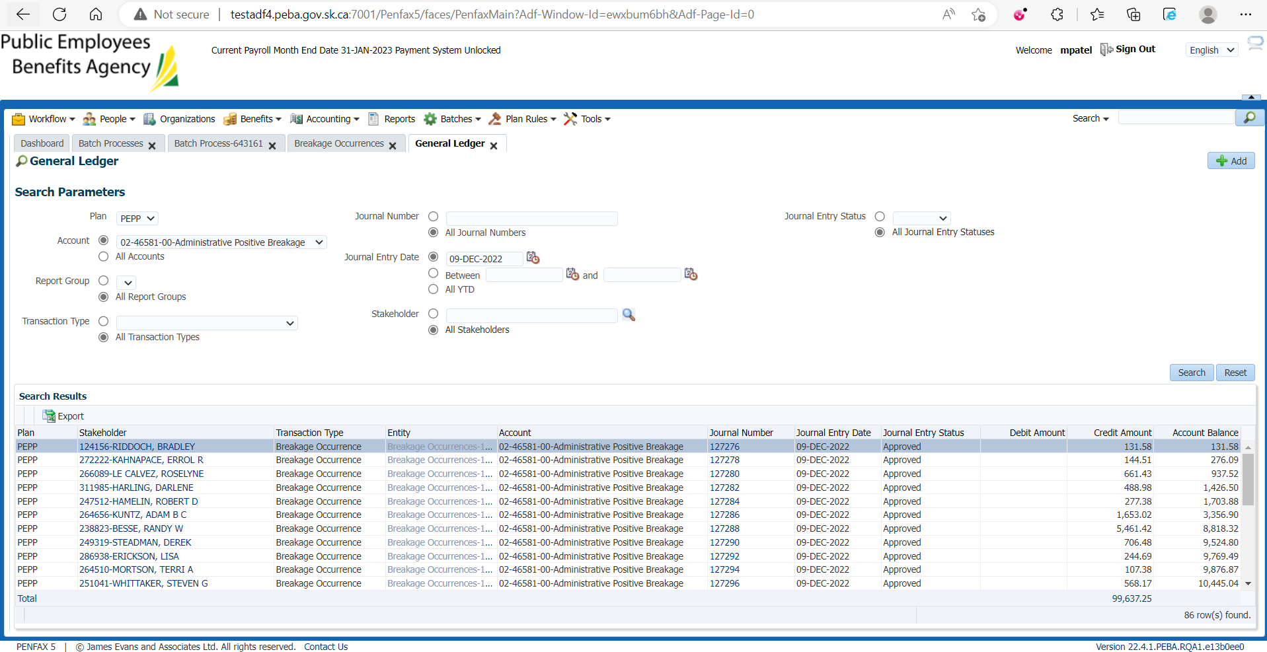

Here, (-143.50) +(131.58) =11.92